**1. INTRODUCTION**

**1.1 OVERVIEW OF SYSTEM**

Autonomous robots are robots that can perform various designated tasks without continuous human guidance.

An autonomous robot has the ability to,

● Gain information about the environment.

● Work for an extended period without human intervention.

● Move either all or part of itself throughout its operating environment without human assistance.

An Artistic robot is a specialized autonomous and mobile robot that is used to draw and paint different shapes.The project is aimed at implementing a system which can extract a vector image from a raster image and draw the same autonomously on a chart paper. Image processing will be used for determining the image to be reproduced. Once the exact image is known we determine the color of image and communicate instructions to proper robot to start creating the image. ZigBEE protocol will be used for communication with the robots.

The development of information technology in the forthcoming decades will demand informatics to leave applications that are exclusively computer-based and instead occupy itself with the development of daily life objects (e.g. white goods, cars, etc.) that contains “intelligence”. A number of skills is needed in order to construct such objects. The skills integrate different competences and not only the ability to make a perfect software application. In general, skills are needed to construct hardware objects that are governed by an “intelligent” or “adaptive” software that continuously interacts with a changing and non-deterministic real world.

This project emcompasses various computer science disciplines like Real Time Robotics,

Embedded Systems, Artificial Intelligence(upto some extent), communication using ZigBEE, Image Processing using Matlab/Scilab, etc. This project is being done under the guidance of ERTS lab, IIT bombay. Thus, it is a great learning experience for us.

**1.2 EXISTING SYSTEM**

The artistic robot domain is relatively untouched at the global level. But a quick google search would reveal that several conceptually similar bots have been created before. These bots mainly create fine arts on walls, or even canvasses. They use expensive cameras for image processing have complex servo-motor run robotic arms that power their drawing utilities.

A fine example of a robot capable of drawing fine arts is one as created by the painter Francois Simon as on the web site <http://paintwithrobots.fr.mu/>.

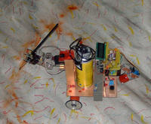

Fig 1: Painting robot

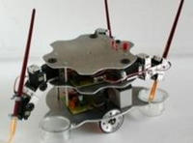

Fig 2: Painting robot

These bots are very expensive and for fine art creation only. We are solving this problem by creating inexpensive robots capable of drawing accurate engineering and architectural images.

**2. LITERATURE REVIEW**

A number of sources were surveyed for the formulation of the exact problem statement and for carrying out the adequate amount of research required to plan and implement a project of such calibre.

Some of the sources are as under:

* **SPARK V MANUALS:**

These are the papers issued by the manufacturers and designers of the SPARK V robot. The manufacturers of the SPARK V robot is nectrobotics.com and the designing is done by ERTS LAB, IIT BOMBAY .We specifically referred to SPARK V ATMEGA16 Robot Research Platform Hardware and Software Manual (COPYRIGHT 2002)[6].

* **RESEARCH PAPERS AT paintwithrobots.fr.mu/:**

These are the research papers of the painter Francois Simon namely, http://paintwithrobots.fr.mu/THE ROBOTPAINTER SCARABOT, who has implemented robots capable of creating fine arts ,and is using them at a commercial level Although not completely useful to us in our project ,it has given us a sort of inspiration[3].

* **MATLAB HELP:**

An essential part of our project is Image Processing, which is required to process the image into its constituent pixel values. Therefore, to help us with accurate coding, apt MATLAB HELP documents have been referred too.

**3. PROBLEM STATEMENT**

It comprises of the creation of a swarm of robots capable of drawing a multicoloured image autonomously. This image can be any complex figure, but to start initially we will be providing simple shapes and objects. This multicoloured image will have the three basic colour components, RGB (Red, Green & Blue).

The entire module consists of a main computer system which will process the required image using Matlab software. The Matlab has inbuilt features to return the pixel matrix of any given input image. It can also break the pixel matrix into its constituent matrices on the basis of the colour, i.e. each different colour amongst RGB will have a different pixel matrix. After further vectorization, the main computer will give the inputs to the bots via Zigbee protocol. Each bot is responsible for drawing the only part of the image that is coloured in the colour it is responsible for (i.e. any one out of RGB).

The robots are equipped with the drawing utility, i.e. a servo motor that is capable of basic up and down motion. This motor controls the movements of a pen/marker/paint etc , i.e. whatever we use as a drawing tool.

**4. REQUIREMENT ANALYSIS**

4**.1 REQUIREMENT ELICITATION**

An artist robot is a specialized autonomous mobile robot that is used to recreate different images as per given input. In this analysis we will describe functionality and requirements of our project.

DEFINITIONS, ACRONYMS AND ABBEREVIATIONS USED ARE:

* Robot:-A robot is a mechanical and electronic device which is designed to perform a specific task. A robot may perform a task under the guidance of a human or on its own.
* Autonomous robot:-An autonomous robot is a robot capable of performing tasks on its own (without assistance of human)*.*
* Swarm:-Swarm is a group of robots which are co-ordinated to perform a task together.

## PRODUCT PERSPECTIVE:

Designing and developing a method for processing image data into commands for motion control for autonomous artistic robot swarm.

## PRODUCT FUNCTION:

Autonomous artistic robots are capable of recreating the image at proper corresponding location as per input on the canvass. The robot swarm consists of three robots controlled and co-ordinated by central control computer.

USER CHRACTERISTICS:

* The user involved has to do the work of starting the system.
* Once the system starts the robots create the image autonomously.
* Once the image has been produces, the system (i.e. robots) stops automatically.
* Users are mostly spectators or art enthusiastic.

**4.2 REQUIREMENT ANALYSIS**

The robots don’t have individual intelligence, they are controlled by a central controller takes the digital image as input and returns commands to robots via wireless medium for motion control.

Each robot has a colouring utility attached to it which may be green, red or blue. The colouring utility is attached to robot by means of a servo motor .The colouring utility can me moved up and down.

**4.3 REQUIREMENT RECORDING**

* A White sheet of paper is to be used as canvass on which robots will recreate digital image.
* Use of the matlab so that proper mapping of digital co-ordinates to physical co-ordinates can be done.
* A central controller which is equipped with image processing and algorithm for converting the image (i.e. image matrix) to motion control commands which are communicated to the robots via a wireless medium.
* Autonomous Robot
* Robotic arm which supports colouring utility
* Programing code
* Sensors:IR sensor
* Colouring tool: pen/marker/paint, which can be attached to the servo motor for drawing an image on the canvas paper.

**4.4 COST ANALYSIS**

|  |  |  |
| --- | --- | --- |
| **COMPONENT DESCRIPTION** | **NO OF UNITS** | **COST** |
| SPARK V ROBOT(inclusive of charging cable and USB cable) | 3 | 2300 * 3 |
| XBEE PC MODULE | 1 | 652.5 |
| XBEE ROBOT MODULE | 4 | 1649*4 |
| VS-1 SERVO MOTOR | 3 | 350*3 |
| PERMANENT MARKERS(R,G,B) | 3 | 20*3 |
| IMPERIAL SIZE SHEETS | 4 | 10*4 |
| PCB CIRCUIT BOARD(including studs) | 3 | 470*3 |

Table 1: cost analysis

**4.5 COMPONENT LIST**

* 3 SPARK V ROBOTS
* 3 CHARGING CABLES FOR ROBOTS
* 3 USB CABLES FOR THE ROBOTS
* 1 XBEE PC MODULE
* 4 XBEE ROBOT MODULES
* 3 VS-1 SERVO MOTOR KITS
* 3 MARKERS(R,G,B)
* IMPERIAL DRAWING SHEET

**5. PROJECT DESIGN**

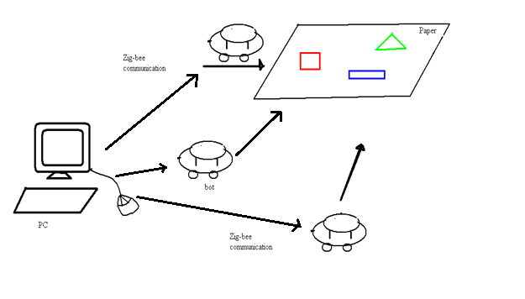

Fig 3: Model system

We are going to design and build a paint robot team which will consist of three robots. These three robots will work together intelligently to create a multicoloured image. The tools we will be using to design these robots will go by discipline.

We have got our hardware from IIT (Bombay). Our team will be using C++ programming language. The project is aimed at implementing a system which can extract a vector image from a raster image and draw the same autonomously on a chart paper. The whole project will be open-source and the code is being implemented using coding standards and standard naming conventions. The code of the Visual Studio will be reusable, readable and portable. The AVR Studio code will be readable and reusable but not portable to other Microcontrollers. The hardware requirements are strict. The software requirements for the Visual Studio are strict. But for Microcontroller code, the IDE is not mandatory but the specific compilers and programmer is required.

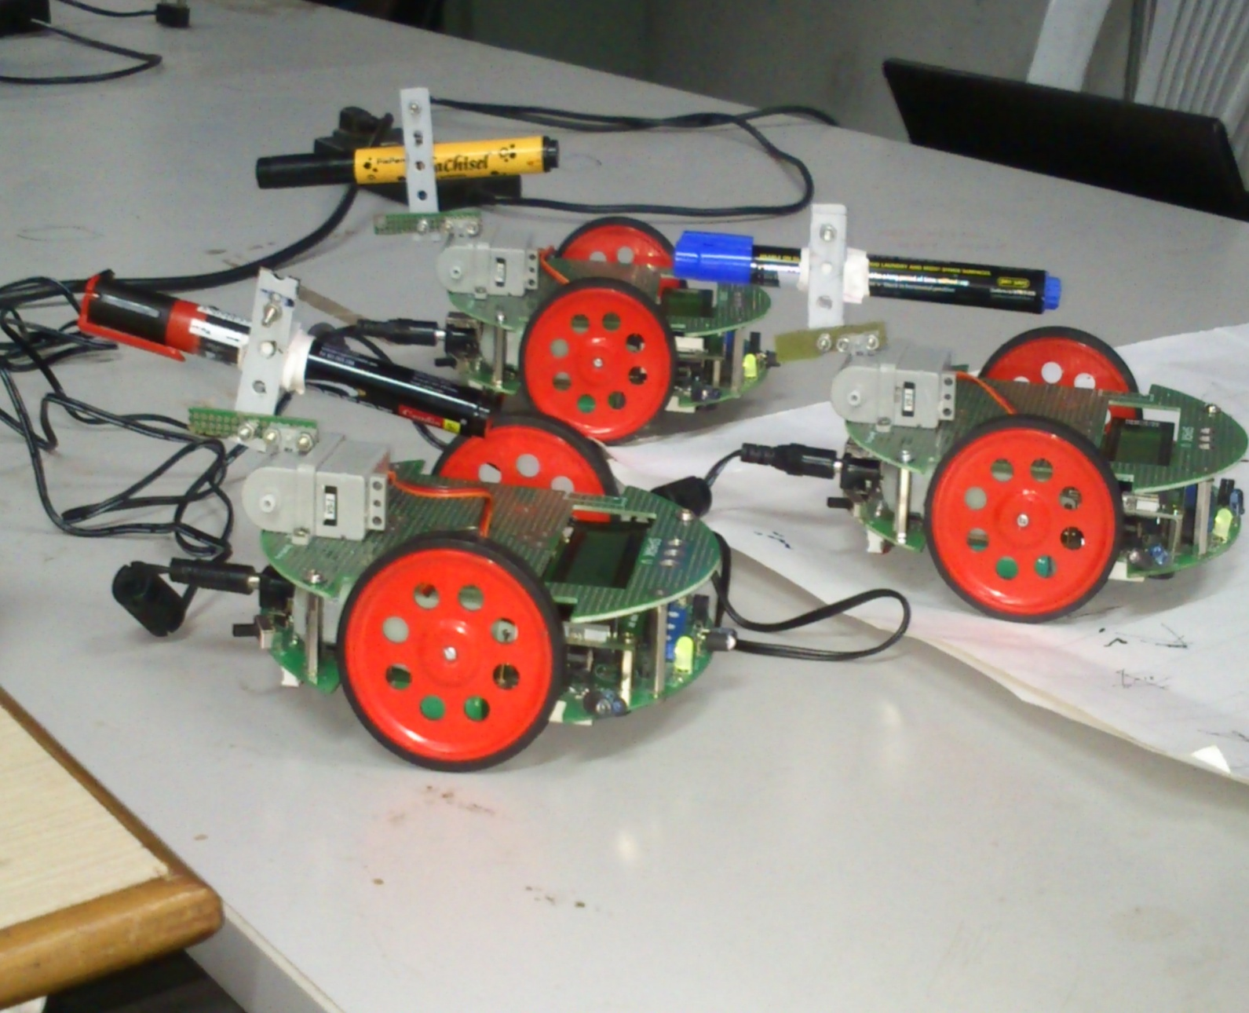

Fig 4: Actual photograph of completed swarm

The software used for image processing is MATLAB

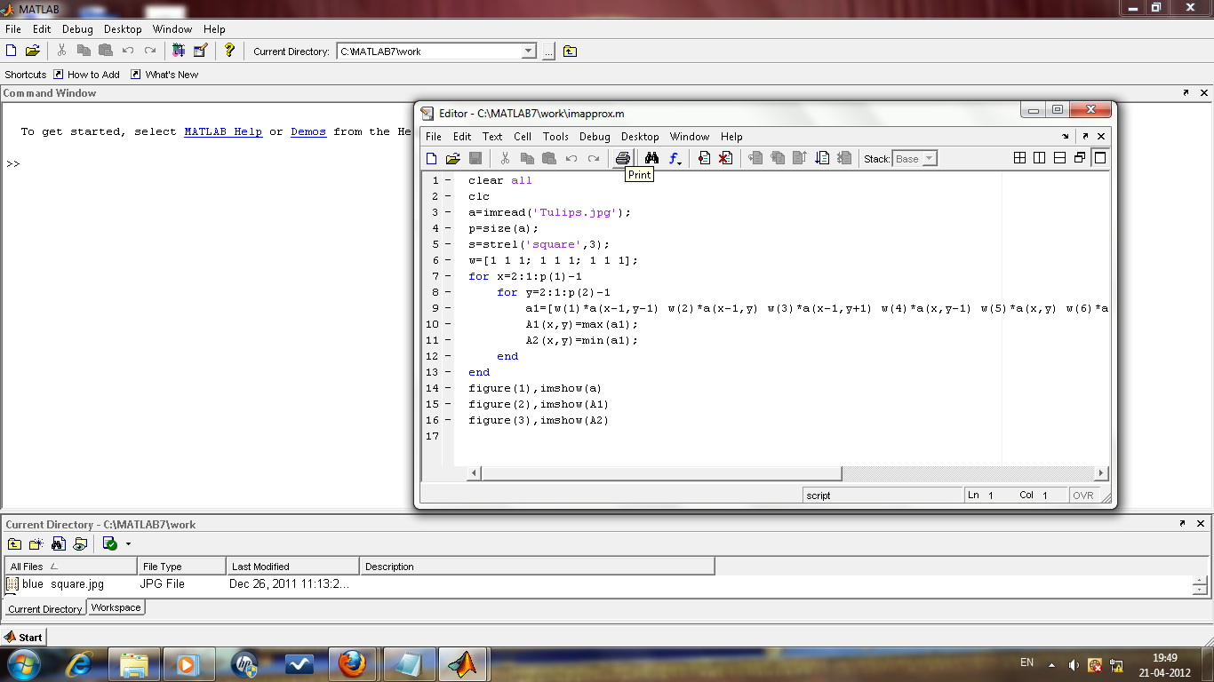

Fig 5: MATLAB screenshot

Software used for embedded programming in C is AVR STUDIO

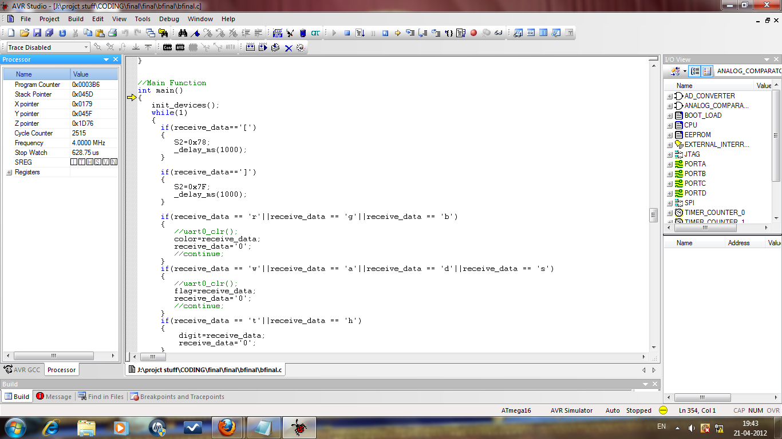

Fig 6. AVR STUDIO screenshot

Software used to burn embedded C program into microcontroller of robot is AVR BOOTLOADER

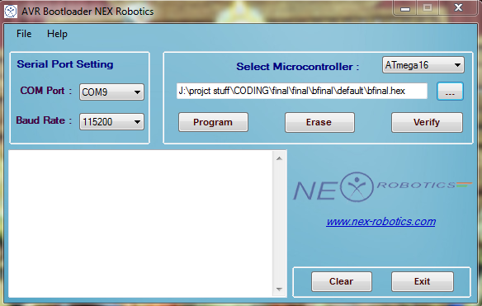

Fig 7. AVR BOOTLOADER screenshot

**6. IMPLEMENTATION DETAILS**

**6.1 FLOW DIAGRAM**

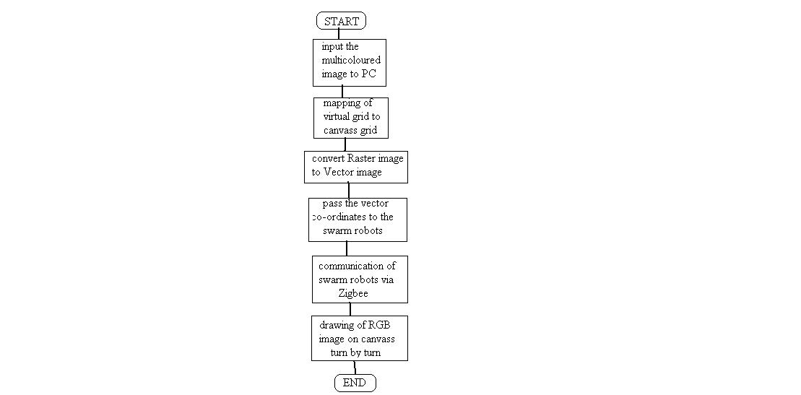

Fig 8: Flow diagram

The flow diagram is as explained below:

The Canvass is a chart or a sheet white in colour. We have a central control PC and 3 assisting robots with different coloured drawing utility. A coloured raster image will be given as input. The raster image is converted to a vector image. The canvass will be mapped to a virtual grid by capturing an image of it prior to beginning of drawing. The image is deciphered and instructions are forwarded from PC to the bots. Depending on colour of shape or image, proper instructions are communicated the instructions to proper robot. The by using the virtual grid,the assisting robots will start creating the image on the canvass. By processing grid information as well as by using colour detection, the robots will be able to determine how much area has been painted and how much area is remaining. Once the image is completely create the robots will go back to their starting positions.

**IMAGE PROCESSING USING MATLAB**

Consider image as below. This is the image given to MATLAB to carry out image processing.



Fig 9: Sample image

The above image is the sample image being given as input to MATLAB.

MATLAB detects the different colours present in the sample image, i.e. R G & B, and processes each colour separately

The 3components get separated at runtime. Only a particular color is highlighted, i.e. made white, rest are merged into background.

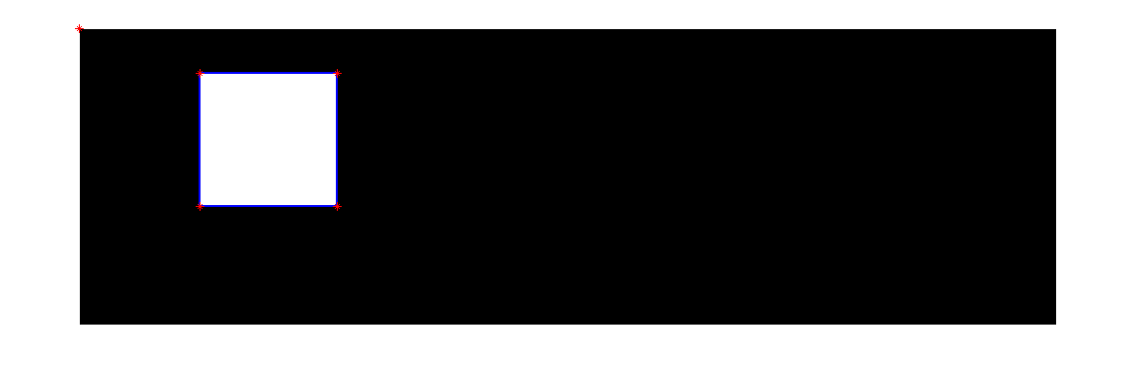 Fig 10: Processing stage 1

****Fig 11: Processing stage 2



Fig 12: Processing stage 3

As is clear from the above images, each shape is colored differently.

MATLAB separates the differently colored shapes at runtime, thus it isolates those parts of the image having different colors, R G & B.

Another function has been developed by us in MATLAB which detects the corner pixels of each shape.

As MATLAB isolates each shape, it detects corner pixels for each shape, denoted by red marking at each shape corner.

Using these corner pixels, MATLAB calculates length of side of the shape and also angle between 2 sides of a shape, which are required by the robot.

**6.2 MAPPING DIGITAL CO-ORDINATES TO PHYSICAL CO-ORDINATES**

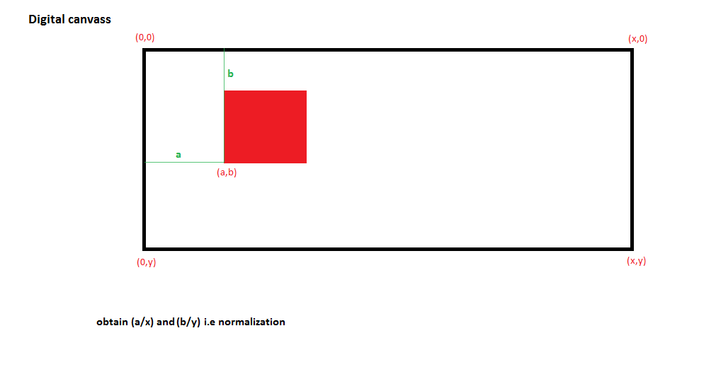

Fig 13: Digital canvass representation

In above image

X=>breadth of digital canvass

Y=> length of digital canvass

a=>x co-ordinate of start point

b=>y co-ordinate of start point

Upon drawing the image as shown above, we select one corner as starting point for drawing the image. We then obtain the digital co-ordinates of point depending upon the application used to create digital image. The digital co-ordinates obtained are the normalized with respect to digital canvass (a/x and b/y).

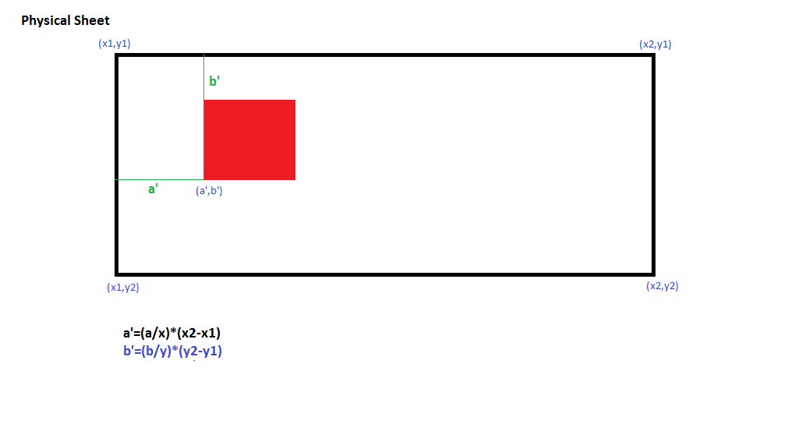

Fig 14: Physical sheet representation

In above image,

X2-X1=>breadth of physical canvass

Y2-Y1=> length of physical canvass

a’=>x co-ordinate of start point

b’=>y co-ordinate of start point

The image of canvass (i.e. sheet) is captured through a camera and using Image processing only the required portion of image is selected.

Then the normalized coordinates obtained from digital image are denormalized using the dimensions of sheet by using the formula given below.

a’=(a/x)*(X2-X1)

b’=(b/y)*(Y2-Y1)

Then the robots start creating the image from this point. This mapping ensures that the digital image given and physical image reproduces are proportionately similar in size and position.

**SETTING UP SWARM ENVIRONMENT**

* Swarm consists of 3 spark V robots
* A Xbee Module with chip antenna will be connected to each of the robot
* A XBee module with USB socket will be connected to controller (PC).
* The controller will the communicate instructions wirelessly to Robots
* Each bot also has a pen/ marker i.e. a colouring utility which is red, green or blue (rgb).
* This utility is powered by a servo motor capable of up down motion

**7. TECHNOLOGIES USED**

1. **MATLAB:-**

#### Development Environment:

* Editor highlighting enhanced to show all uses of a variable or subfunction and identify shared variables.
* Ability to manage ZIP files as folders in the Current Folder Browse.
* File previews in Current Folder Browser that show image file contents and unsaved content in MATLAB files.
* Access to additional toolbox plots in the Plot Selector, including plots for System Identification, Mapping, and Bioinformatics Toolbox.
* Comparison Tool enhanced, allowing comparison among ZIP files, folders, and Simulink manifests, and improving MAT-file comparisons.

#### Language and Programming:

* Ability to define custom enumerated data types with sets of named values.

#### Mathematics:

* Support for arithmetic on 64-bit integer types.

#### File I/O and External Interfacing:

* New VideoWriter object for creating Motion JPEG and uncompressed AVI files larger than 2 GB.
* netCDF 4.0.1 support, enabling use of HDF5 as the data storage layer for the netCDF API.
* Enhanced interface to Microsoft® .NET framework, supporting delegates and interaction with Microsoft Office products.

### Simulink 7.6:-

#### Component-Based Modelling:

* New array-of-buses capabilities for compact representation of structured data and efficient iterative processing using For Each subsystems
* Variant Subsystem blocks for managing design alternatives
* Expanded support for referencing a model multiple times in normal mode, improving component workflows, linearization, and model coverage analysis

#### Data Management:

* Expanded support for defining root-level, input-port signal data using MATLAB structures and timeseries objects.
* Enhanced Signal Builder block with ability to import multiple test cases from Excel®, MATLAB, and CSV files.
* Enhanced from File block, providing additional interpolation control and support for enumerated data.
* Expanded enumerated data-type support to define multiple enumerated types in a single MATLAB file.
* Data-type specification to include bus object.

1. **Windows AVR:-**

It is basically used to write the code for the microcontroller of the robot. The language in which it is written is basically C/C++ which are low-level languages.

1. **AVR Bootloader:-**

It is software which is basically used for burning the program written in Microvisionkeil into the microcontroller of the robot.

1. **Spark V robot :-**

Spark V is a low cost robot designed for robotics hobbyists and enthusiasts. It is jointly designed by NEX Robotics with Department of Computer Science and Engineering, IIT Bombay. Spark V robot is based on ATMEGA16 microcontroller. It has 3 analog white line sensors, 3 analog IR Proximity sensors, 3 directional light intensity sensors and Battery voltage sensing. Robot has support for 3 MaxBotix EZ series ultrasonic range sensors. It also has support for the servo mounted sensor pod which can be used to make 180 degrees scan for the map making. Robot can be powered by 6 AA size rechargeable NiMH batteries. Robot has built-in Smart Battery Controller which charges the battery in intelligent way and also monitors the battery charge level when robot is in operation. Robot has onboard FT232 based true USB to serial TTL converter. Robot programming is done using NEX Robotics Bootloader via USB port. There is no need to use external programmer. Robot has 2x16 alphanumeric LCD, Lots of LED indicators and Buzzer etc. for quick debugging. Robot has on-board socket for XBee wireless module for multi robot and robot to PC communication. Robot has two low power 60 RPM DC geared motors which are powered by L293D motor driver with the top speed of 66cm/second.

**SPARK V Block Diagram :-**



Fig 15: SPARK V Block Diagram

**SPARK V ATMEGA16 technical specification**

**Microcontroller:** ATMEL ATMEGA16

**Programming:** Using NEX Robotics Boot loader via USB port (no need of separate

programmer)

**Sensors:**

Three white line sensors

Three IR proximity sensors

Three directional light intensity sensors

Two Position Encoders (optional)

MaxBotix EZ series ultrasonic range sensors (optional)

Servo mounted Ultrasonic Range Sensor (optional)

Battery voltage sensing

**Indicators:**

2 x 16 Characters LCD

Indicator LEDs

Buzzer

Battery low indication

**Locomotion:**

Two 60 RPM DC geared motors and caster wheel as support.

Built-in clutch for protection of the motors from non continuous wheel stalling.

Top Speed: 66cm/second.

SPARK V ATMEGA16 Hardware Manual

© NEX Robotics Pvt. Ltd. and ERTS Lab IIT Bombay, INDIA 9

**Operational Modes:**

Standalone (Autonomous Control)

PC as master and robot as slave

Distributed (multi robot communication)

**Communication:**

USB Communication using FT232 USB to Serial Converter

Simplex infrared communication (From infrared remote to robot)

ZigBee (IEEE 802.15.4) (Wireless) (Robots to Robots and Robots to PCs )(Optional)

**Dimensions:**

Diameter: 15cm

Height: 7cm

**Power:**

6 AA size NiMH rechargeable batteries (Batteries not included)

Onboard Smart Battery Controller charges the battery in intelligent way and also monitors the

battery charge level when robot is in operation.

**Locomotion:**

Two 60 RPM DC geared motors and caster wheel as support

Built-in clutch protection for the motors from non-continuous stalling of the wheel

Top Speed: 66cm/second

**Optional Accessories**:

Servo mounted Ultrasonic range sensor for 180 degree scan

Servo mounted directional light intensity sensor for 180 degree scan

Two position encoders

MaxBotix EZ series ultrasonic range sensors

XBee wireless module

**Software Support:**

GUI Based control, AVR studio, WINAVR

Microsoft robotics studio Visual Programming Language (will be launched shortly)

**Requires:**

AC adaptor with exact 12VDC with 1Amp.current rating for battery charging..

Six NiMH rechargeable batteries.

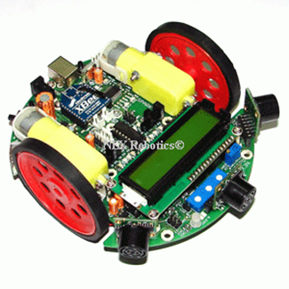

Fig 16: SPARK V robot

**5. Colouring Utility :-**

The colouring utility is a marker attached to a robotic arm kind of arrangement which is actuated by means of a VS1 servo motor.

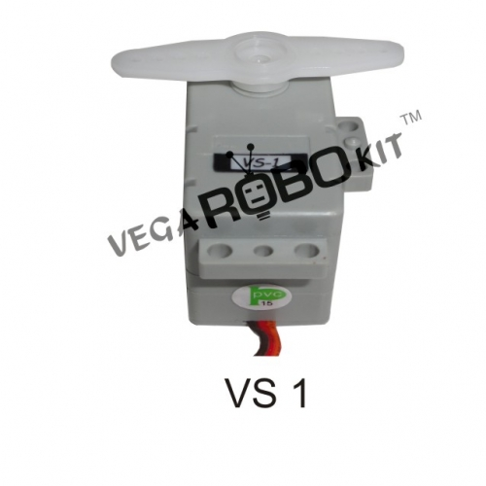

Fig 17: VS1 servo motor

**Technical specifications of VS1 servo motor:-**

* Operating Voltage : 4.8-6.0V
* PWM Input Range : Pulse Cycle 20±2ms, Positive Pulse 1~2ms
* STD Direction : Counter Clockwise / Pulse Traveling 1500 to 1900µsec
* Stall Torque : 3.6 kgf.cm (50.04 oz/in) at 4.8V,4 kgf.cm (55.6 oz/in) at 6V
* Operating Speed : 0.23sec/ 60° at no load at 4.8V, 0.18 sec/ 60° at no load at 6V
* Weight : 34g (1.19 oz)
* Size : 40.5 x 20.2 x 33.7mm
* Plug Available : FUT, JR
* Special Feature : Robot Type

**6.XBee/ Zigbee Wireless Module:-**

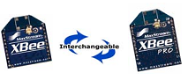

Fig 18:XBee/ Zigbee Wireless Module

The XBee and XBee-PRO OEM RF Modules were engineered to meet IEEE 802.15.4 standards and support the unique needs of low-cost, low-power wireless sensor networks. The modules require minimal power and provide reliable delivery of data between devices. The modules operate within the ISM 2.4 GHz frequency band and are pin-for-pin compatible with each other.

The XBee/XBee-PRO RF Module was designed to mount into a receptacle (socket) and therefore does not require any soldering when mounting it to a board. The XBee Development Kits contain RS-232 and USB interface boards which use two 20-pin receptacles to receive modules.

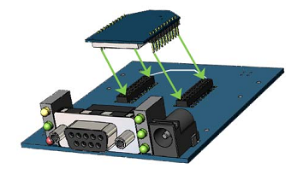

Fig 19: XBee/ Zigbee transmitter

The receptacles used on MaxStream development boards are manufactured by Century Interconnect. Several other manufacturers provide comparable mounting solutions; however, MaxStreamcurrently uses the following receptacles:

• Through-hole single-row receptacles - Samtec P/N: MMS-110-01-L-SV (or equivalent)

• Surface-mount double-row receptacles - Century Interconnect P/N: CPRMSL20-D-0-1 (or equivalent)

• Surface-mount single-row receptacles - Samtec P/N: SMM-110-02-SM-S

**8. TEST CASES**

**STAGE 1: ATTACHING SERVO MOTOR TO ROBOT**

The servo motors are attached onto the robot and other required hardware modifications are made to the robot body.

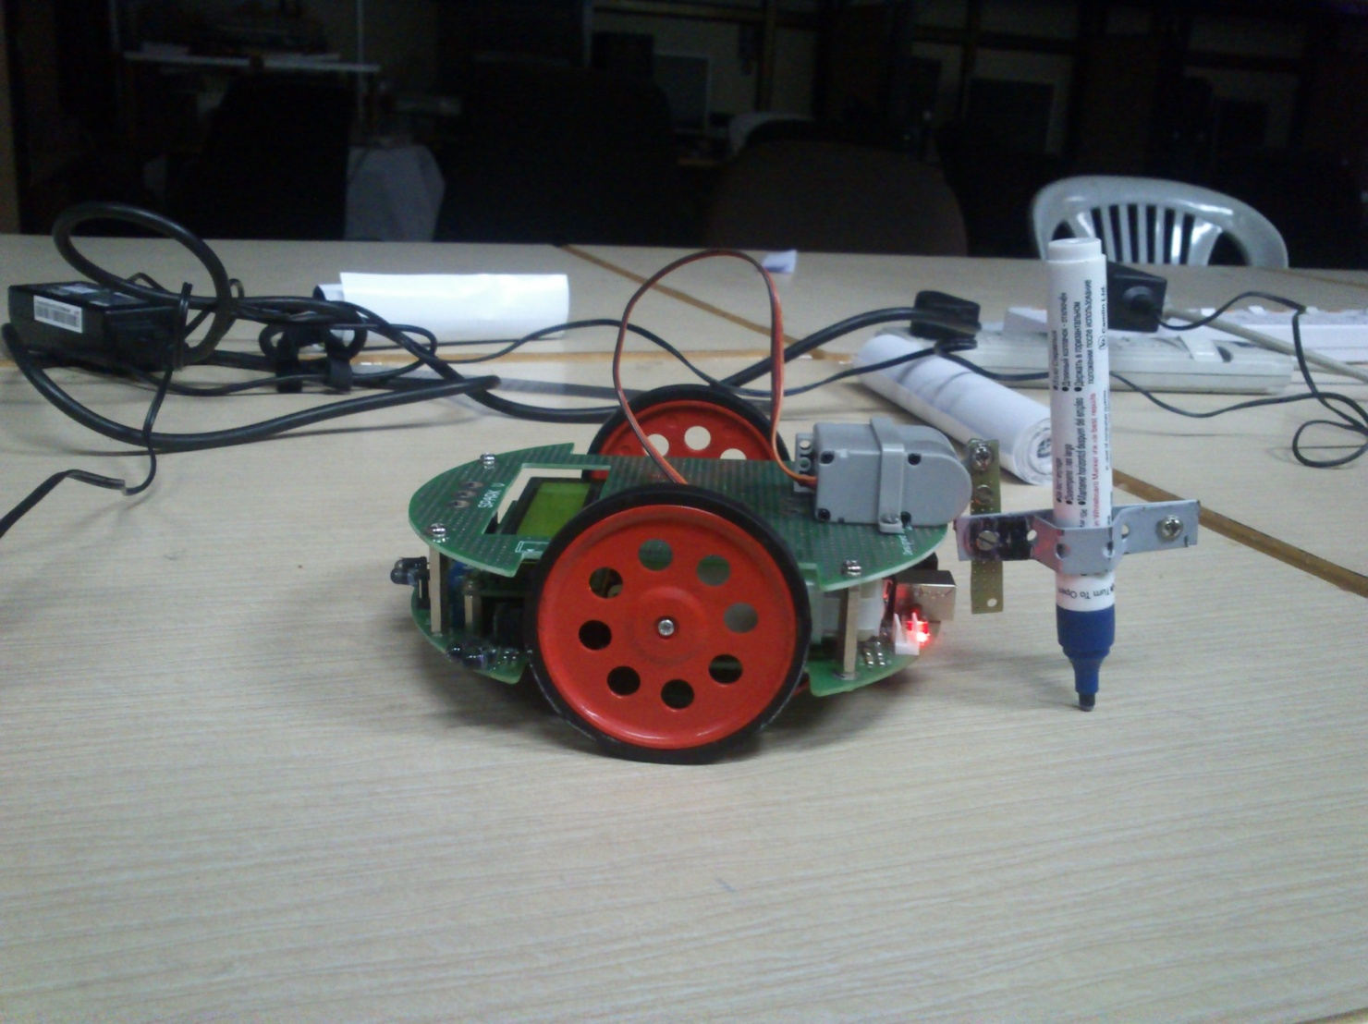 Fig 20: robot with servo motor

**STAGE 2: MOVING ROBOT ALONG A STRAIGHT LINE**

The SPARK V robot is first made to move along a straight line, by programming its PWMs to function at constant speeds. Thus straight line movement of the robot is configured.

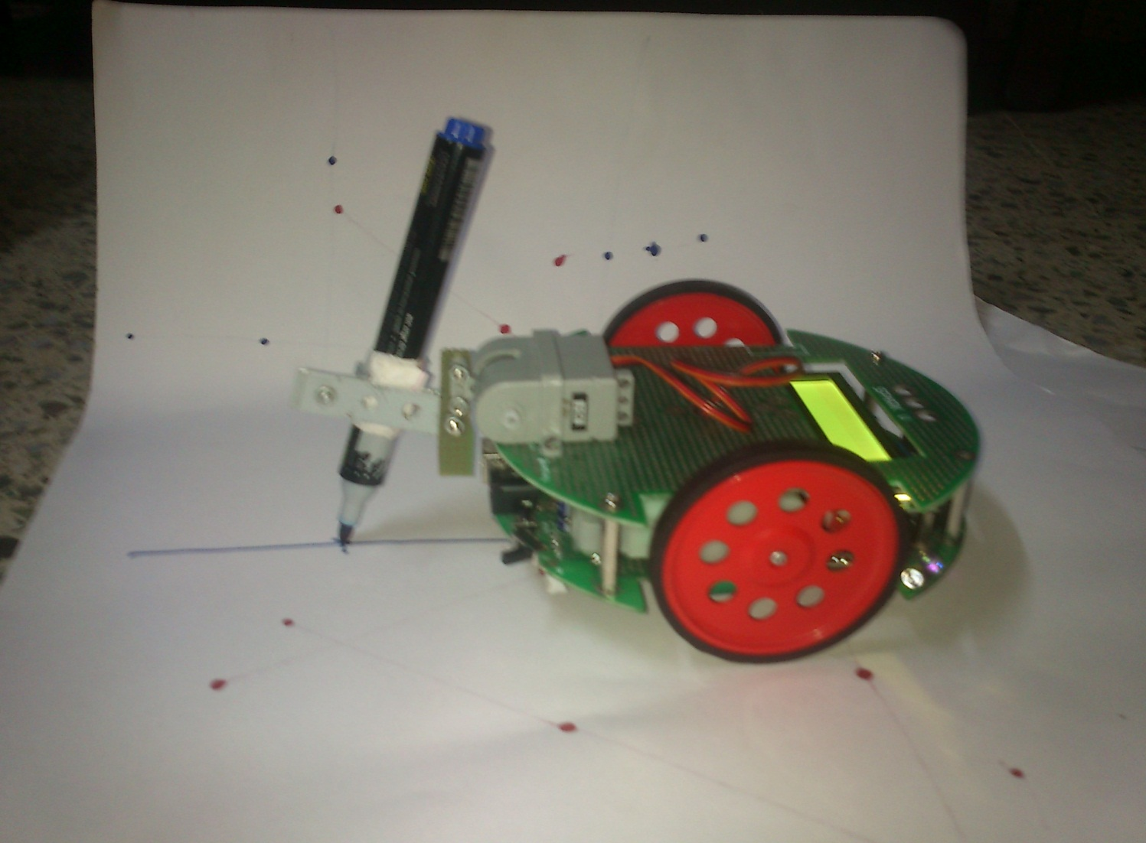

Fig 21: Robot with servo motor drawing straight line

**STAGE 3: MAKING ROBOT TURN ALONG A PARTICULAR ANGLE**

An important stage in robot configuration is making the robot to turn along any particular angle. This makes the robot to turn at any angle to draw any particular shape or figure.

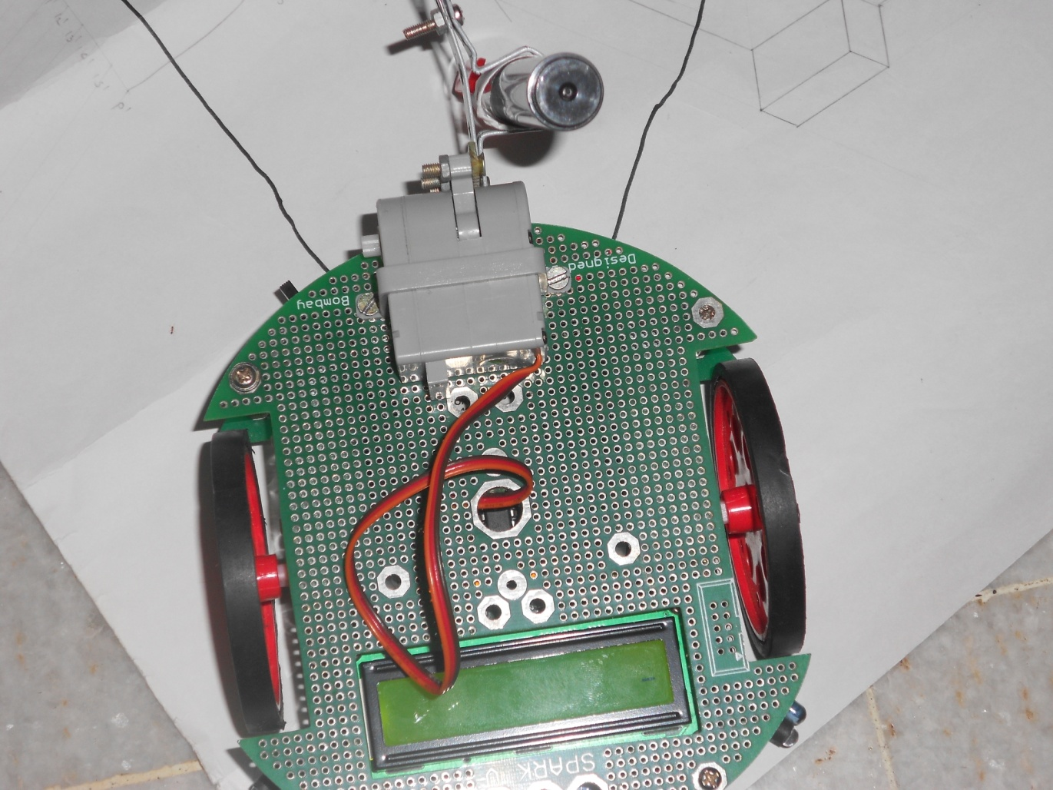

Fig 22: robot with servo motor drawing angles.

**STAGE 4: TRAVERSING ROBOT ALONG THE EDGES OF ANY PARTICULAR SHAPE**

Once the robot is able to move along straight lines and turn around at any angle, it is then made capable to move along any shape boundary.

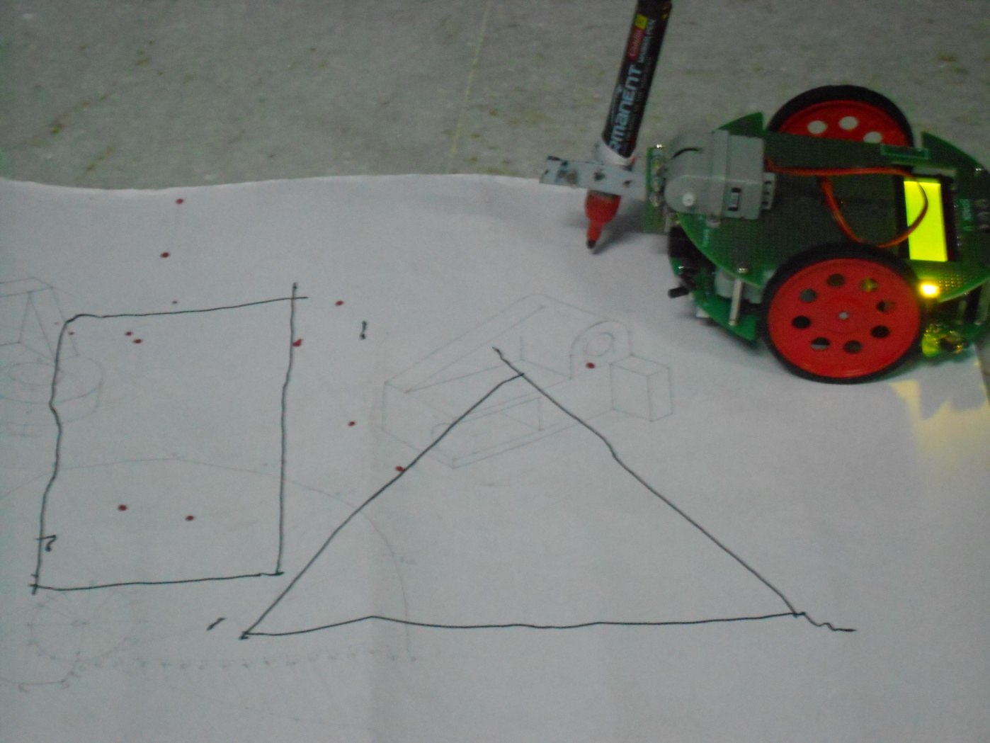

Fig 23: robot with servo motor drawing diff images.

**STAGE 5 : DRAWING THE REQUIRED SHAPES**

Once the servo motors are attached, by their up and down programmed motion, and by the robots accurate traversal, any required drawing can be created.

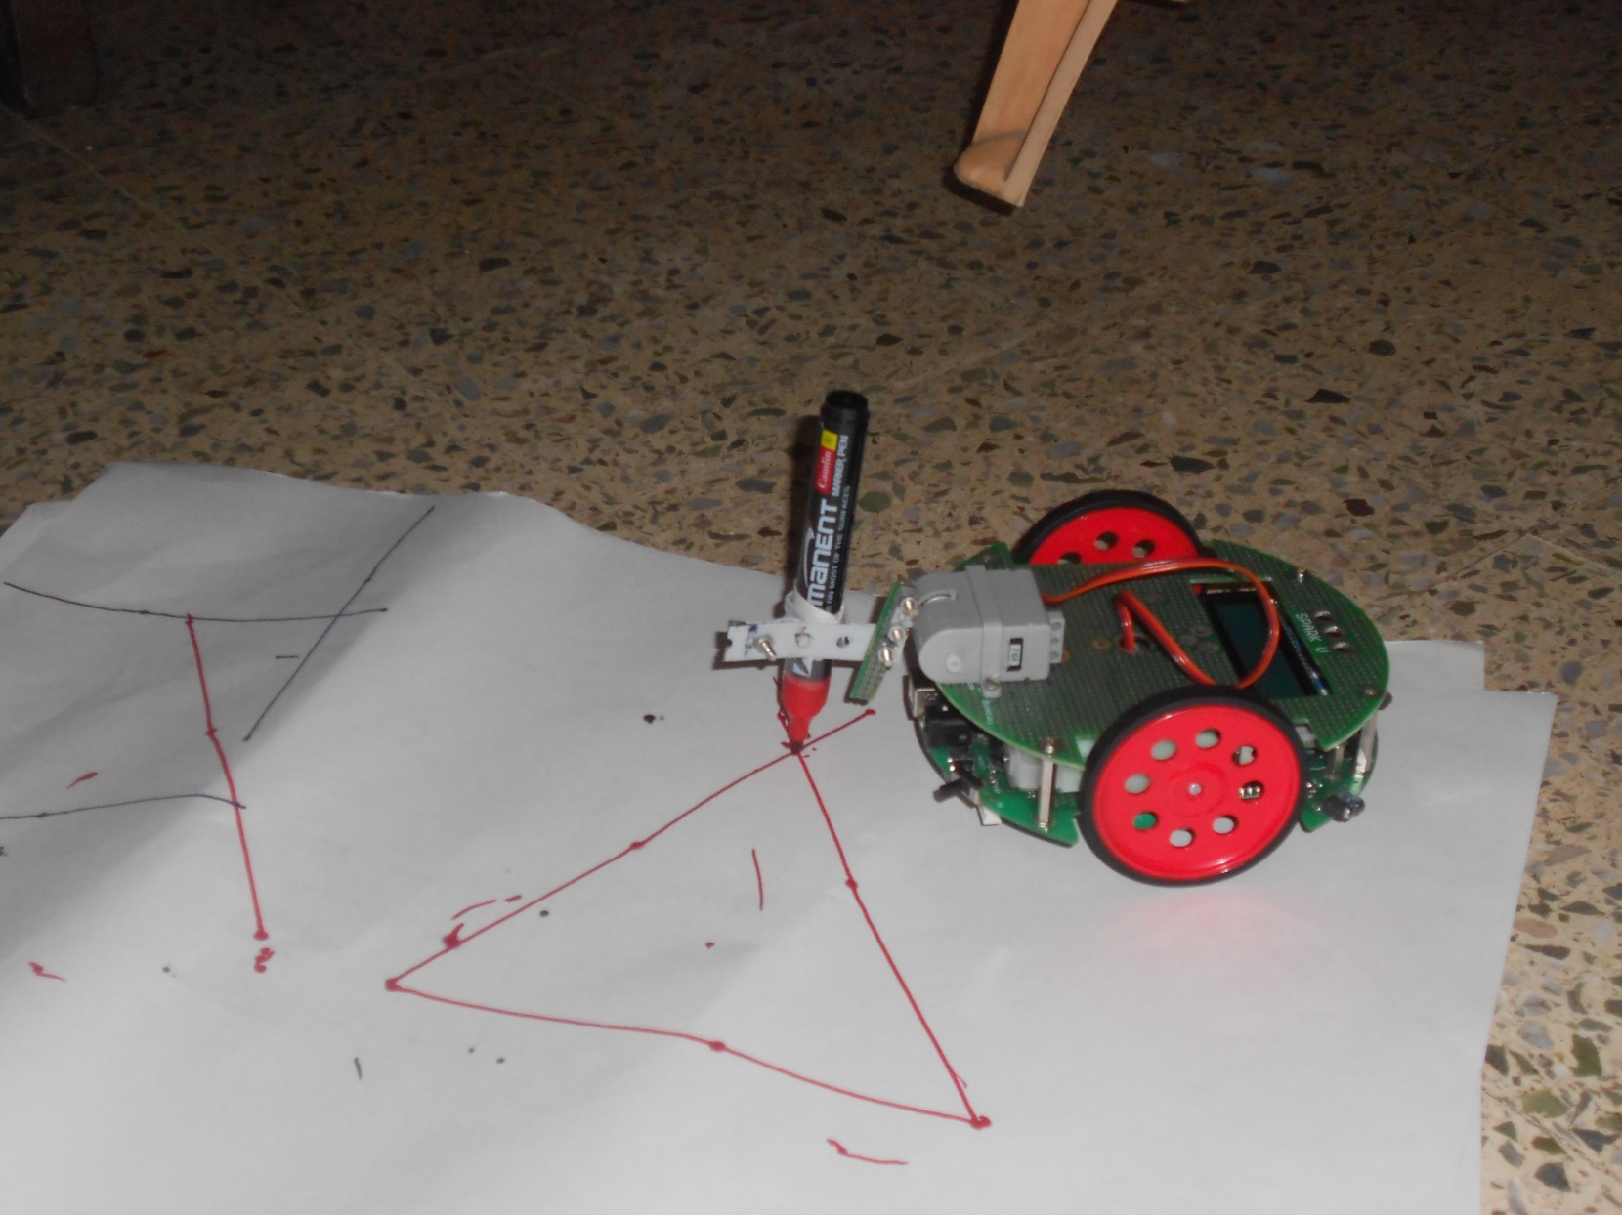

Fig 24: robot with servo motor drawing shape in real time.

**9.PROJECT TIME LINE CHART**

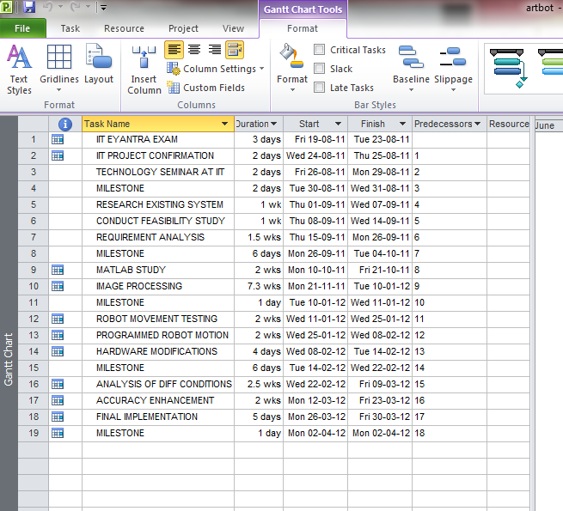

Fig 25: Project time line chart

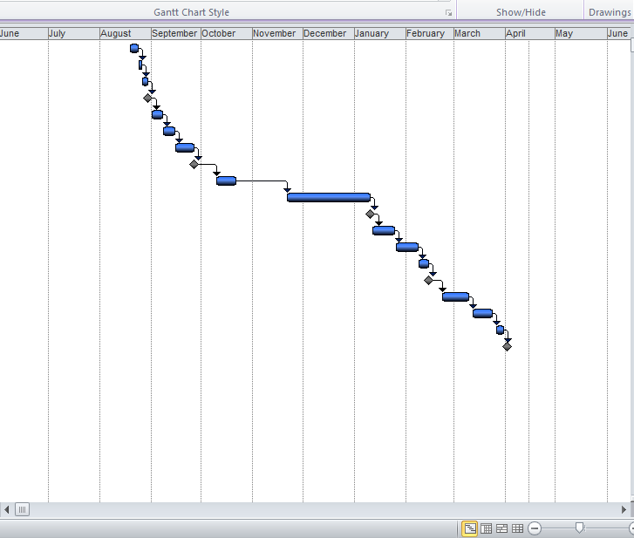

Fig 26: Gantt chart

**10.TASK DISTRIBUTION**

|  |  |  |  |  |
| --- | --- | --- | --- | --- |
| **SR**  **No.** | **Task** | **Ganesh** | **Bhavesh** | **Vineet** |
| 1. | Deciding the Project |  |  |  |
| 2. | IIT Entrance Exam |  |  |  |
| 3. | Topic Finalization at IIT |  |  |  |
| 4. | Topic Finalization in College |  |  |  |
| 5. | Research on project |  |  |  |
| 6. | Identifying phases of project |  |  |  |
| 7. | Software Study |  |  |  |
| 8. | Hardware Study |  |  |  |
| 9. | Robot testing & Image Processing |  |  |  |
| 10. | Core Code Design |  |  |  |
| 11. | Wireless Interfacing |  |  |  |
| 12. | Hardware Modification |  |  |  |
| 13. | Testing & Accuracy Enhancement |  |  |  |
| 14. | Presentation & Black Book Prep. |  |  |  |
| 15. | Final Implementation |  |  |  |

Table2: Task distribution

**ADVANTAGES:**

* Faster creation of drawings than human hand
* More accurate creation of all kinds of drawings as compared to human hand
* Able to automate creation of all kinds of drawings
* Images of all 3 colours can be created simultaneously and quickly.

**DISDVANTAGES:**

* Reduction in human touch to drawings.
* Drawings will only be replications of human created images, any errors done by humans will only be replicated by the robot. The robot is not intelligent enough to improve the images created by humans.
* The accuracy of such systems depends highly on the programming done on the robots. If there is any error in the robot’s code then the system will give errors.

**LIMITATIONS:**

* The system we have created uses an 8-bit microcontroller. Hence accuracy of the system is not limited.
* A mechanical defect present in almost all SPARK V robots is that the PWMs, (Pulse Width Modulators) which are responsible for wheel rotation of the robot are not synchronized. Hence sometimes there is a difference in the wheel velocity of the 2 wheels of the robot, because of which the robot cannot move absolutely straight.
* Being an 8-bit microcontroller, calculation capacity is limited. Hence the robot cannot actually rotate along any specific angle. There is always an error of +/- 8-9 degrees. Only straight lines can be created, no curves can be drawn currently by this robot.
* The swarm of robots we have created will detect and draw shapes in only the 3 basic colours red, green n blue. No shades of these 3 colours can be detected or drawn currently.

**11. CONCLUSION**

Hence we have created a system which is completely autonomous in its drawing capability. We have used a research platform robot called a SPARK V which is has a microcontroller called ATMEGA 16 and some basic sensors and interfaces for any required attachment. The software (MATLAB, AVR) and hardware (servo motor attachments) have been so programmed and designed so as to support all the different essential functionalities of the system. Important aspects of image processing are handled by MATLAB. AVR STUDIO handles the programming of the microcontroller. XBEE wireless modules are used to handle wireless communication. Thus we have been able to cover so many different technologies and aspects. These technologies together make sure that the system is accurately autonomous.

**12. FUTURE SCOPE**

The future scope of the project we have created is very vast. A whole number of design modifications n additions can be carried to improve our system. Basically the robot can be made to fill colour into images that it is drawing. Apart from this the system can be made to a completely professional unit; this system can be modified to automate the creation of any sort of symmetrical and asymmetrical figures. The field where this system will be most useful is for the creation of `various kinds of complex architectural and engineering drawings. Humans take a lot of time to draw such images and may make errors which these robots will not. These robots can bear high levels of artificial independence which will be handy for them in various drawing scenarios. These robots can also be designed to create fine arts.

**13. REFERENCES**

[1 ] www.nex-robotics.com/spark-v-robot.html

[2] www.e-yantra.org

[3] Paintwithrobots.fr.mu , http://paintwithrobots.fr.mu/THE ROBOTPAINTER SCARABOT

[4] *A thinning algorithm by contour generation*, Paul. C. K. Kwok, Communications of the ACM, November 1988 .

[5] *Raster-to-vector Conversion by Line Fitting Based on Contours and Skeletons*, Osamu Hori and SatohideTanigawa, Research and Development Center, Toshiba Corporation1, KomukaiToshibic-cho, Saiwai-ku, Kawasaki 210, JAPAN .

[6] SPARK V ATMEGA16 Robot Research Platform Hardware and Software Manual.